Axxon Device Configuration Guide with GCX-ONE
This document describes the steps required to configure an Axxon device in GCX-ONE.

Step 1: Log in to GCX-ONE.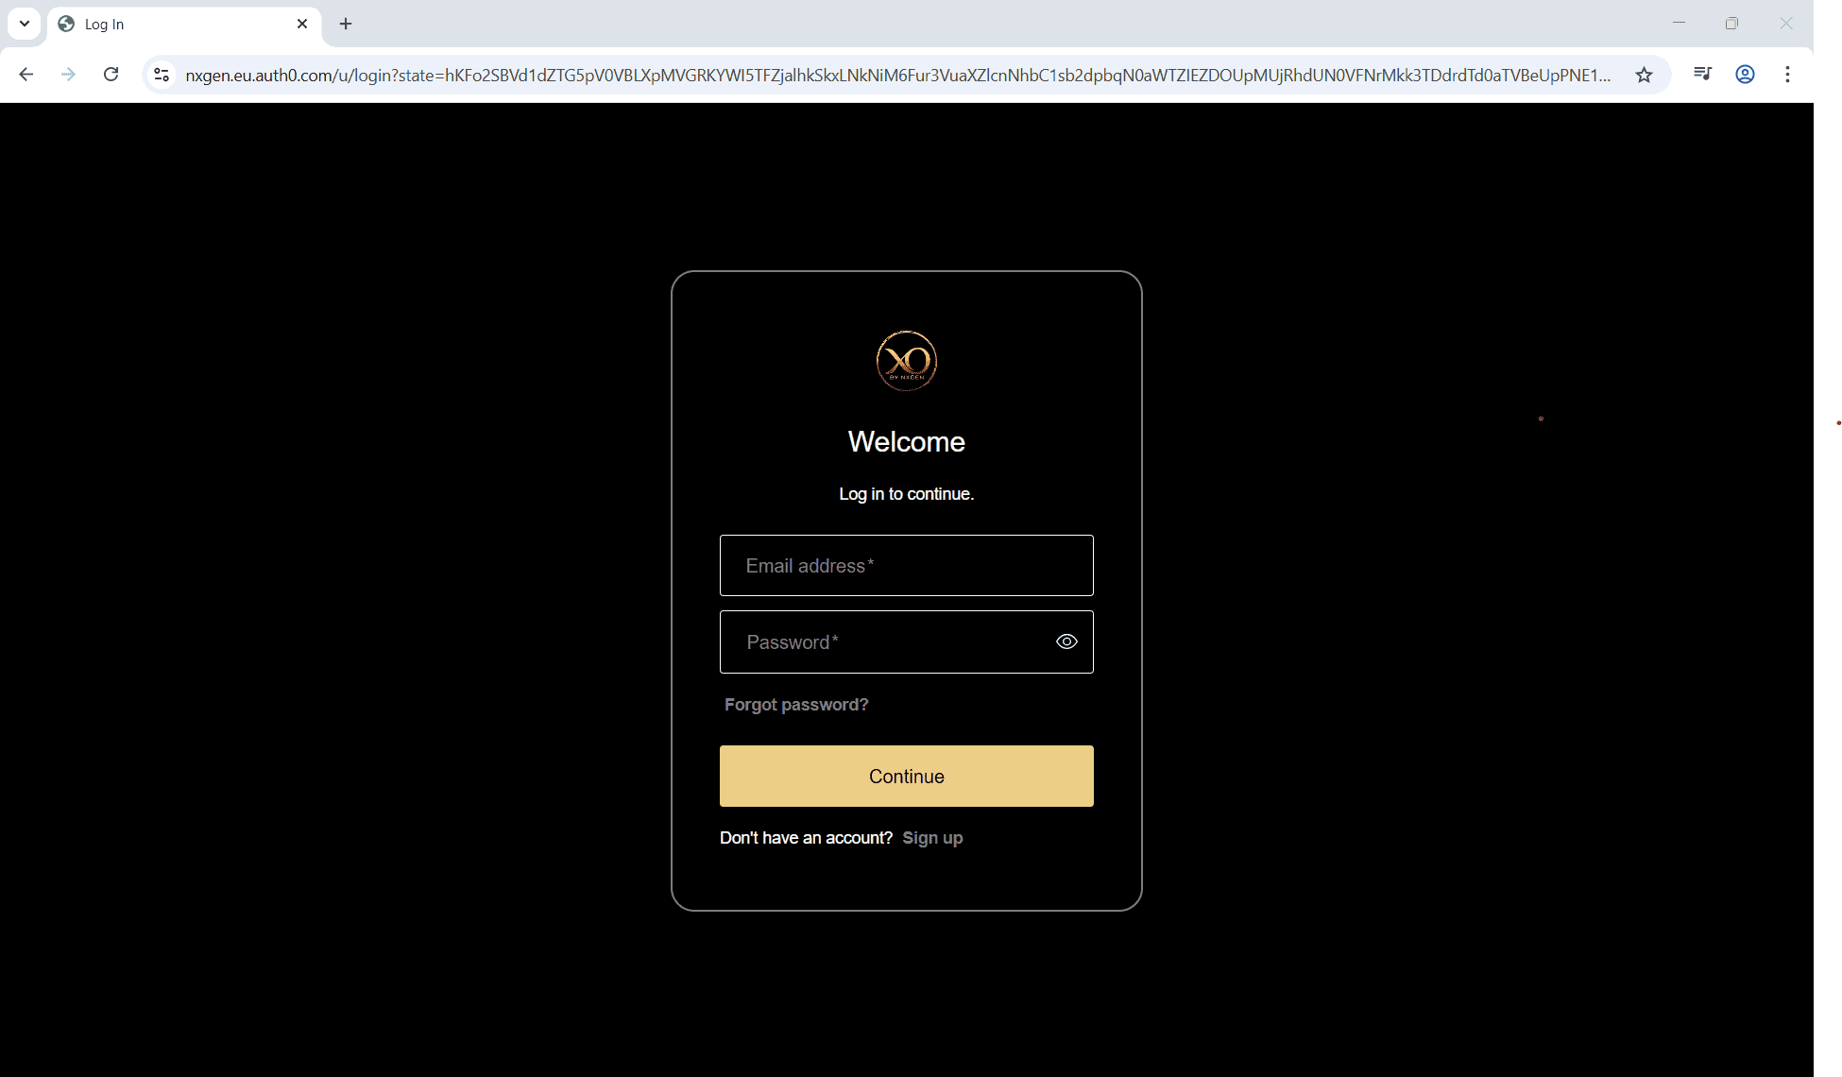
Step 2: Click on the Configuration menu.
Step 3: At the Service Provider level, click on Customers.
Step 4: Click the Add button.
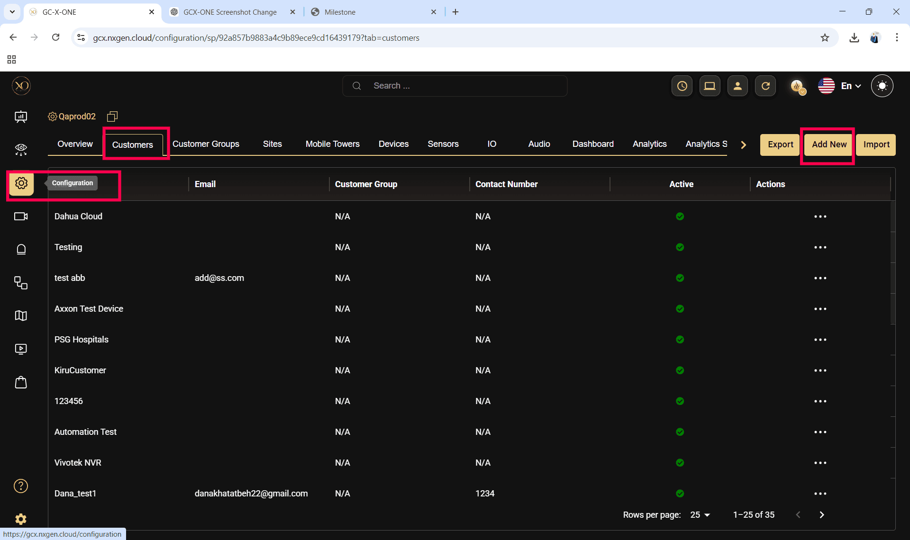

Step 5: Enter the required fields and click Save.
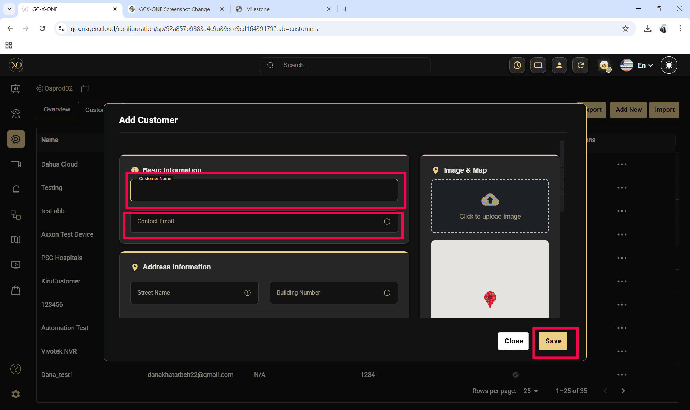
Step 6: Select the newly created customer.
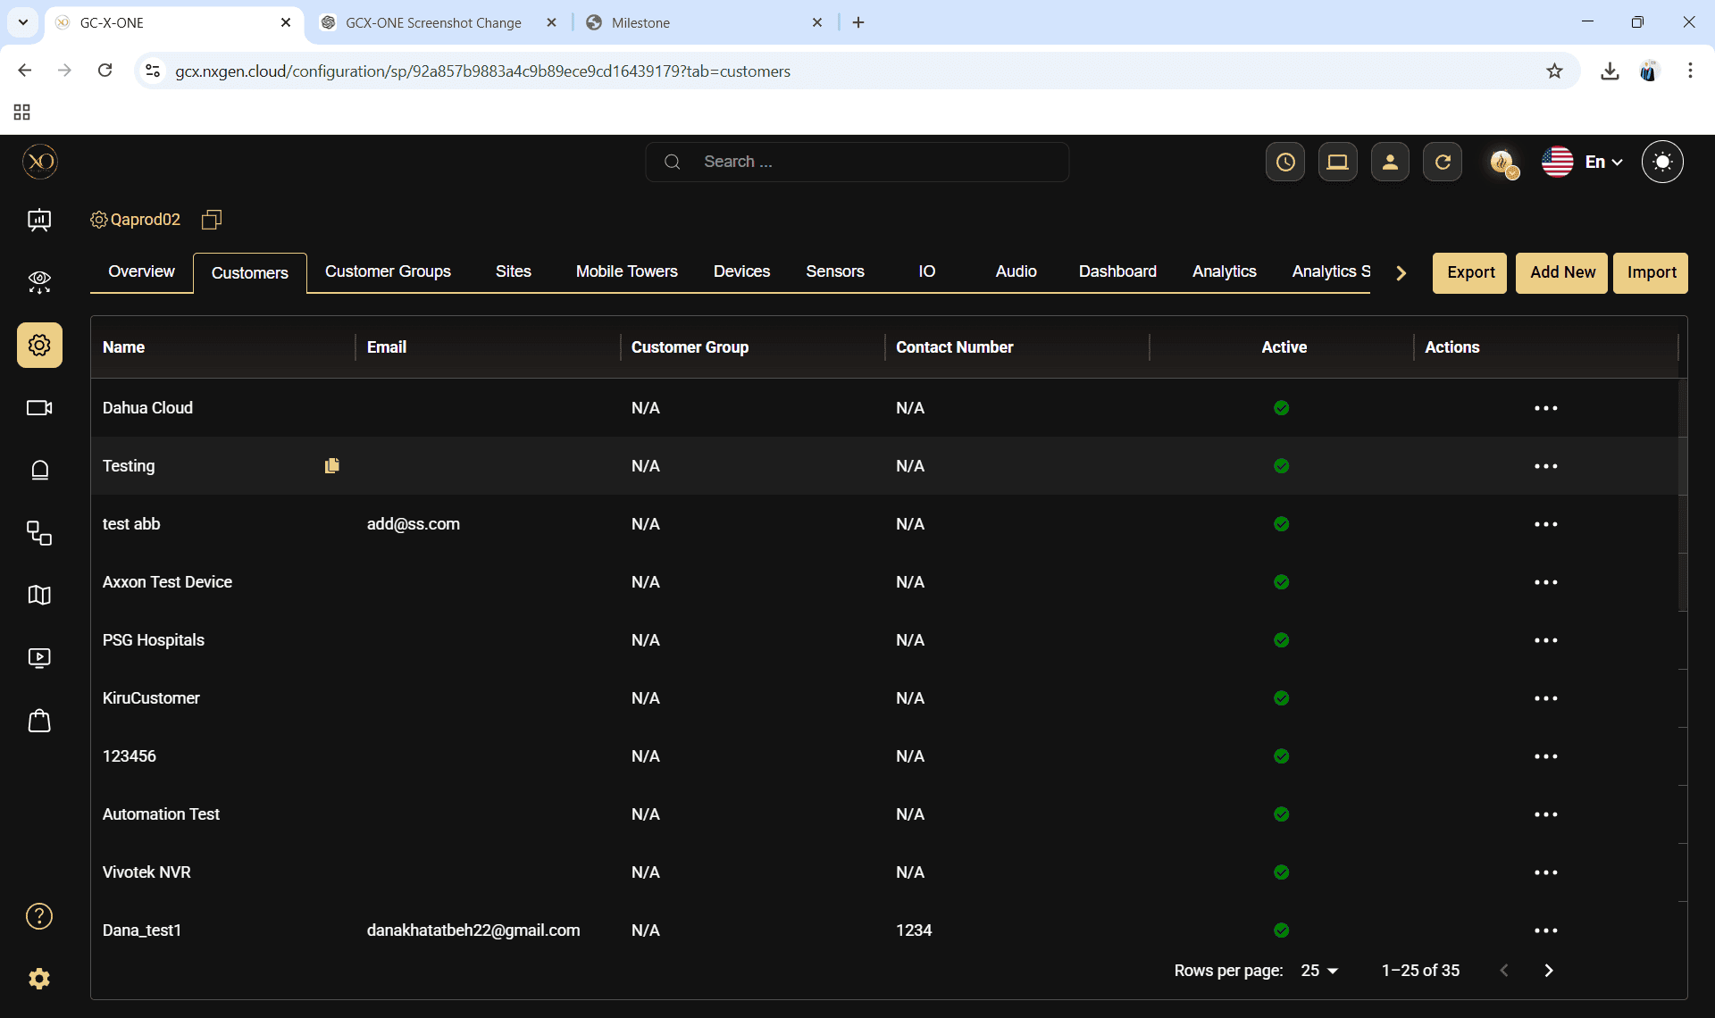

Step 7: Navigate to the Sites tab.
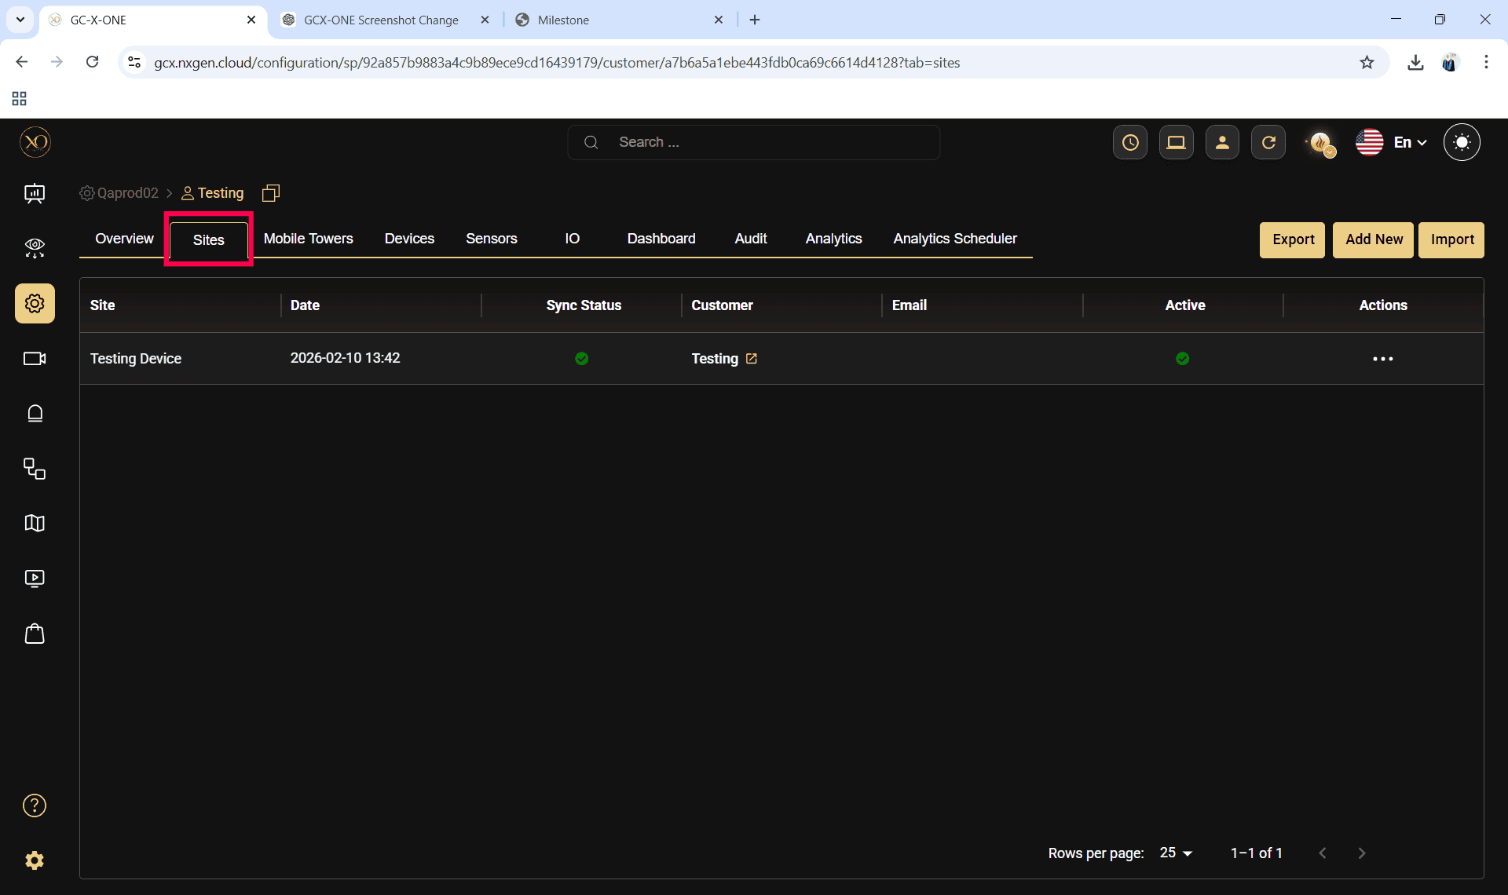
Step 8: Click the Add button.
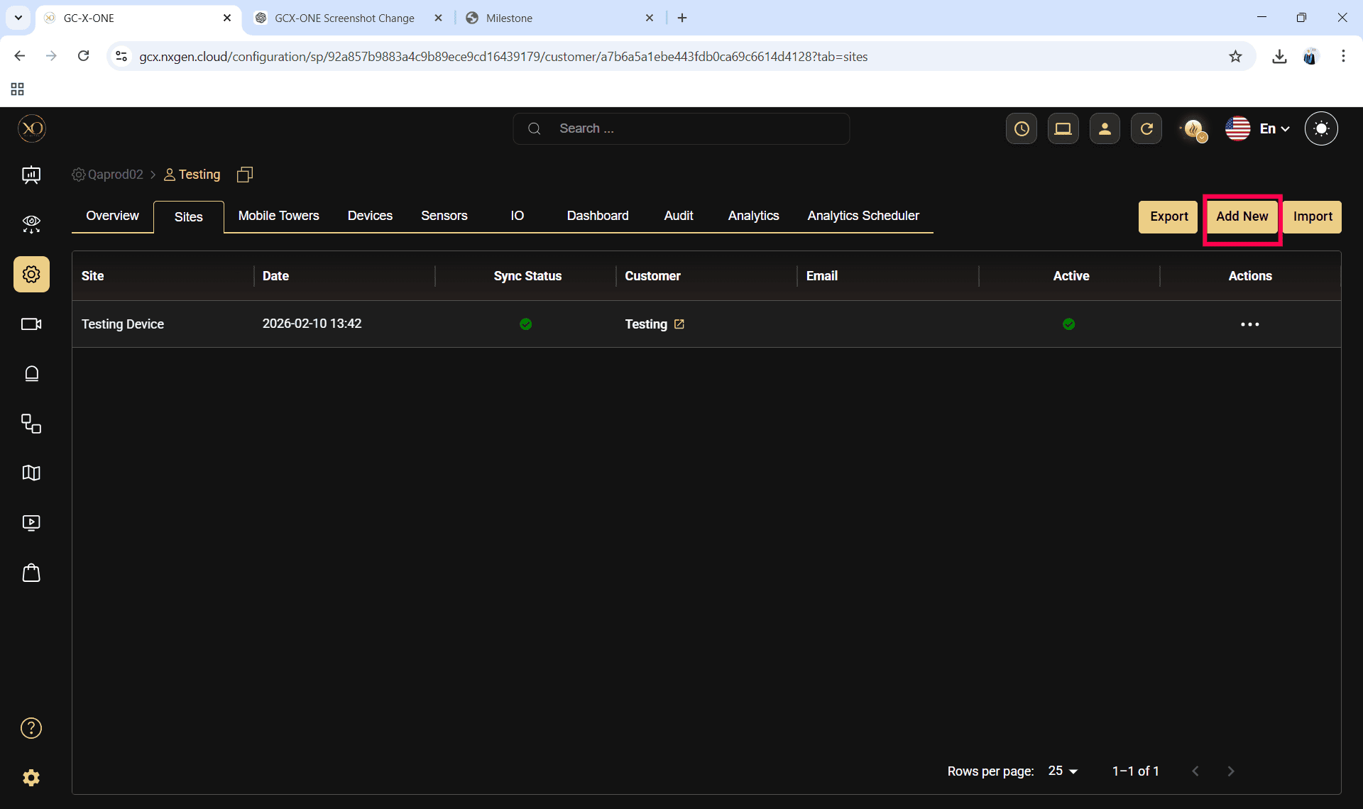

Step 9: Enter the required fields and click Save.
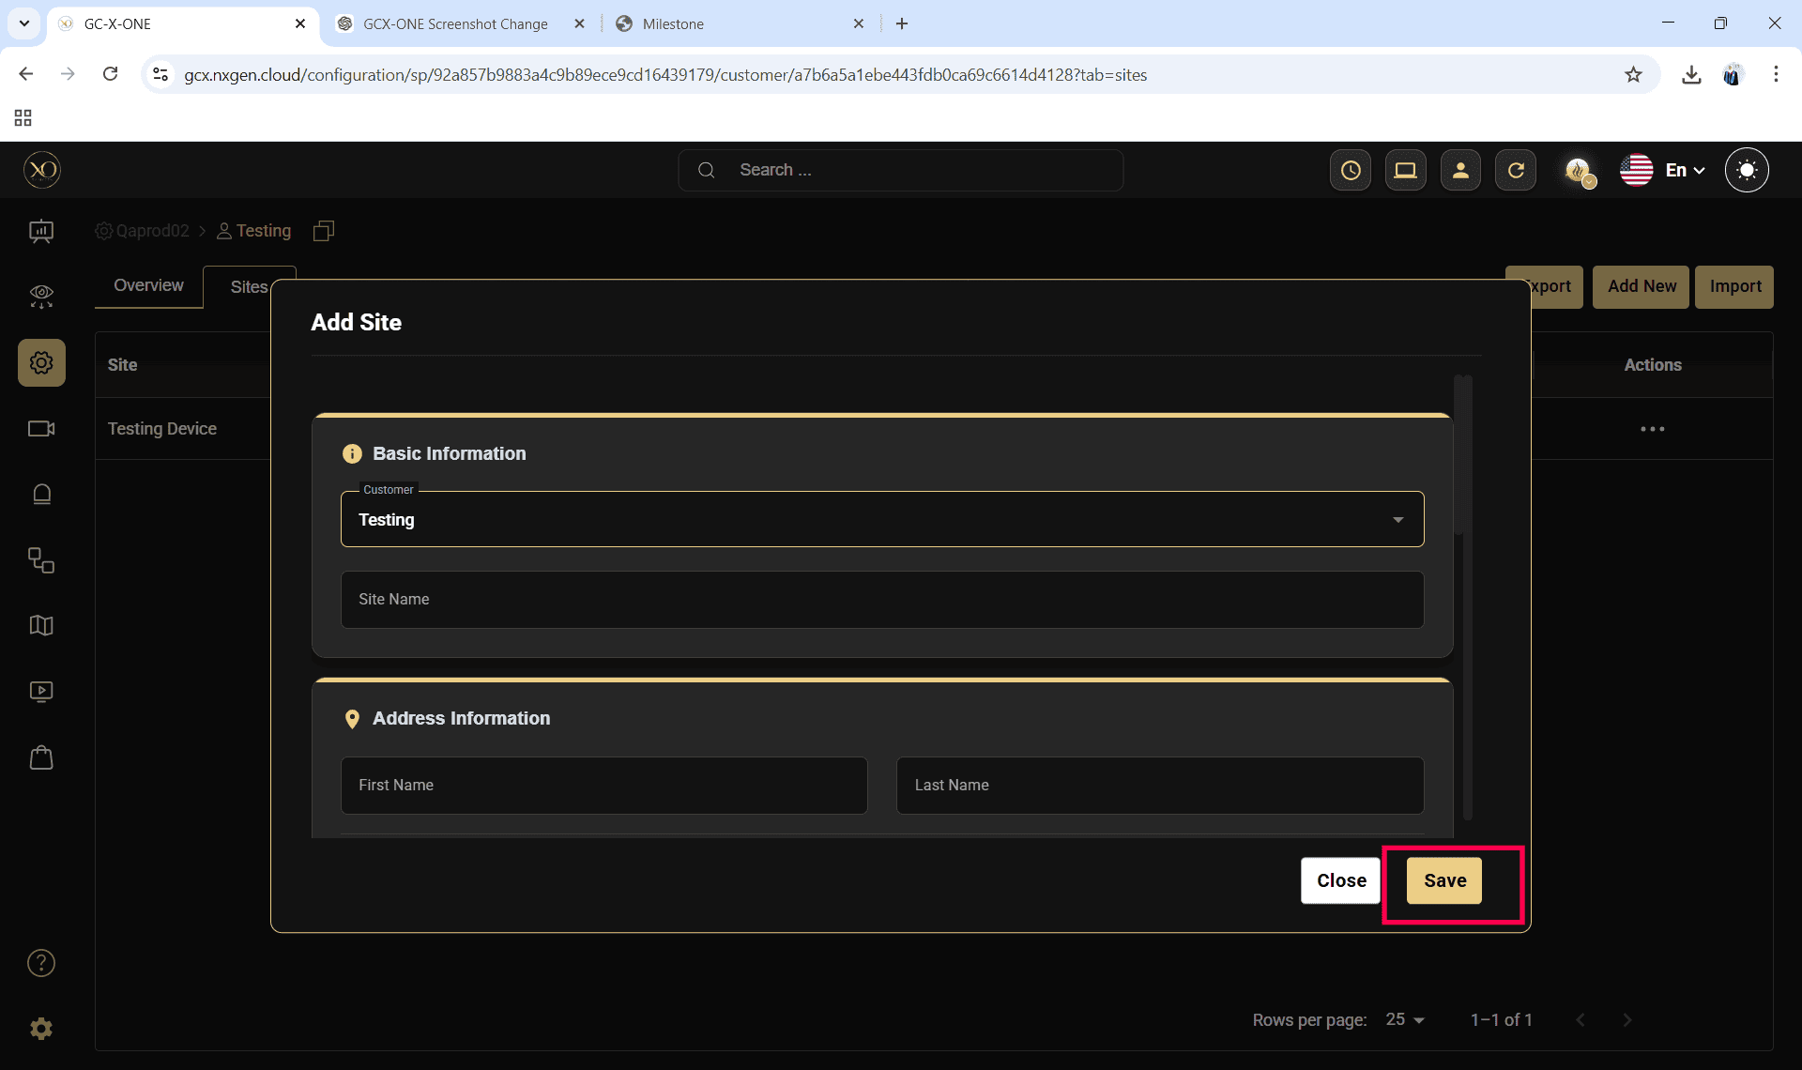

Step 10: Select the newly created site.
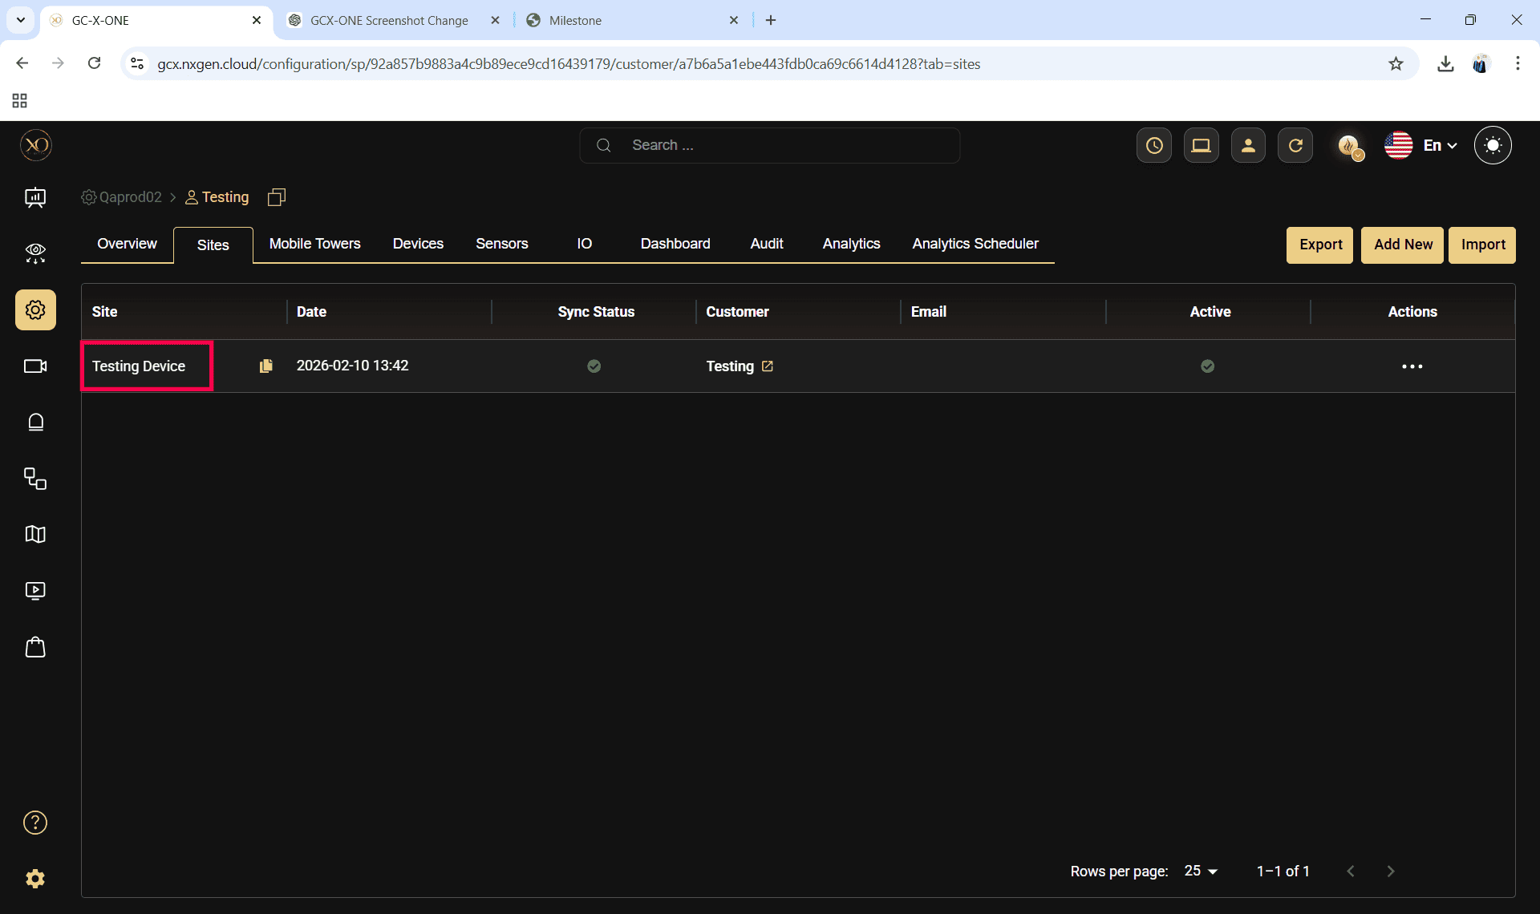

Step 11: Navigate to the Devices tab.
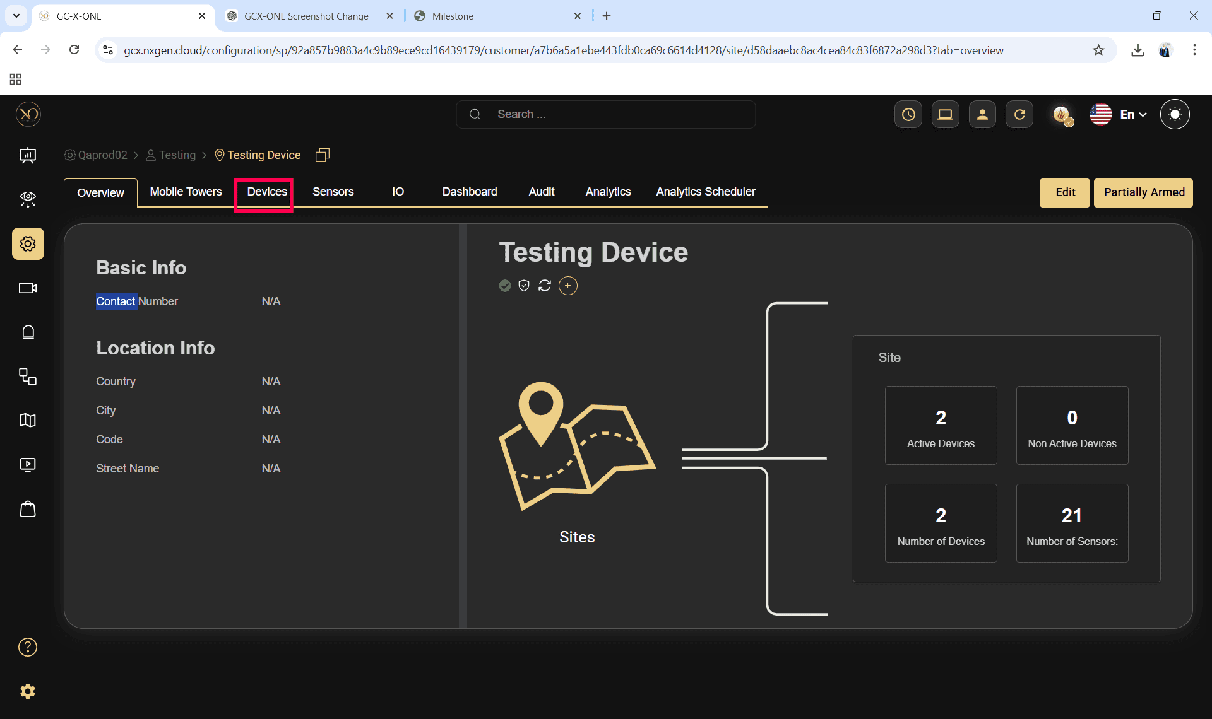
Step 12: Click the Add button.
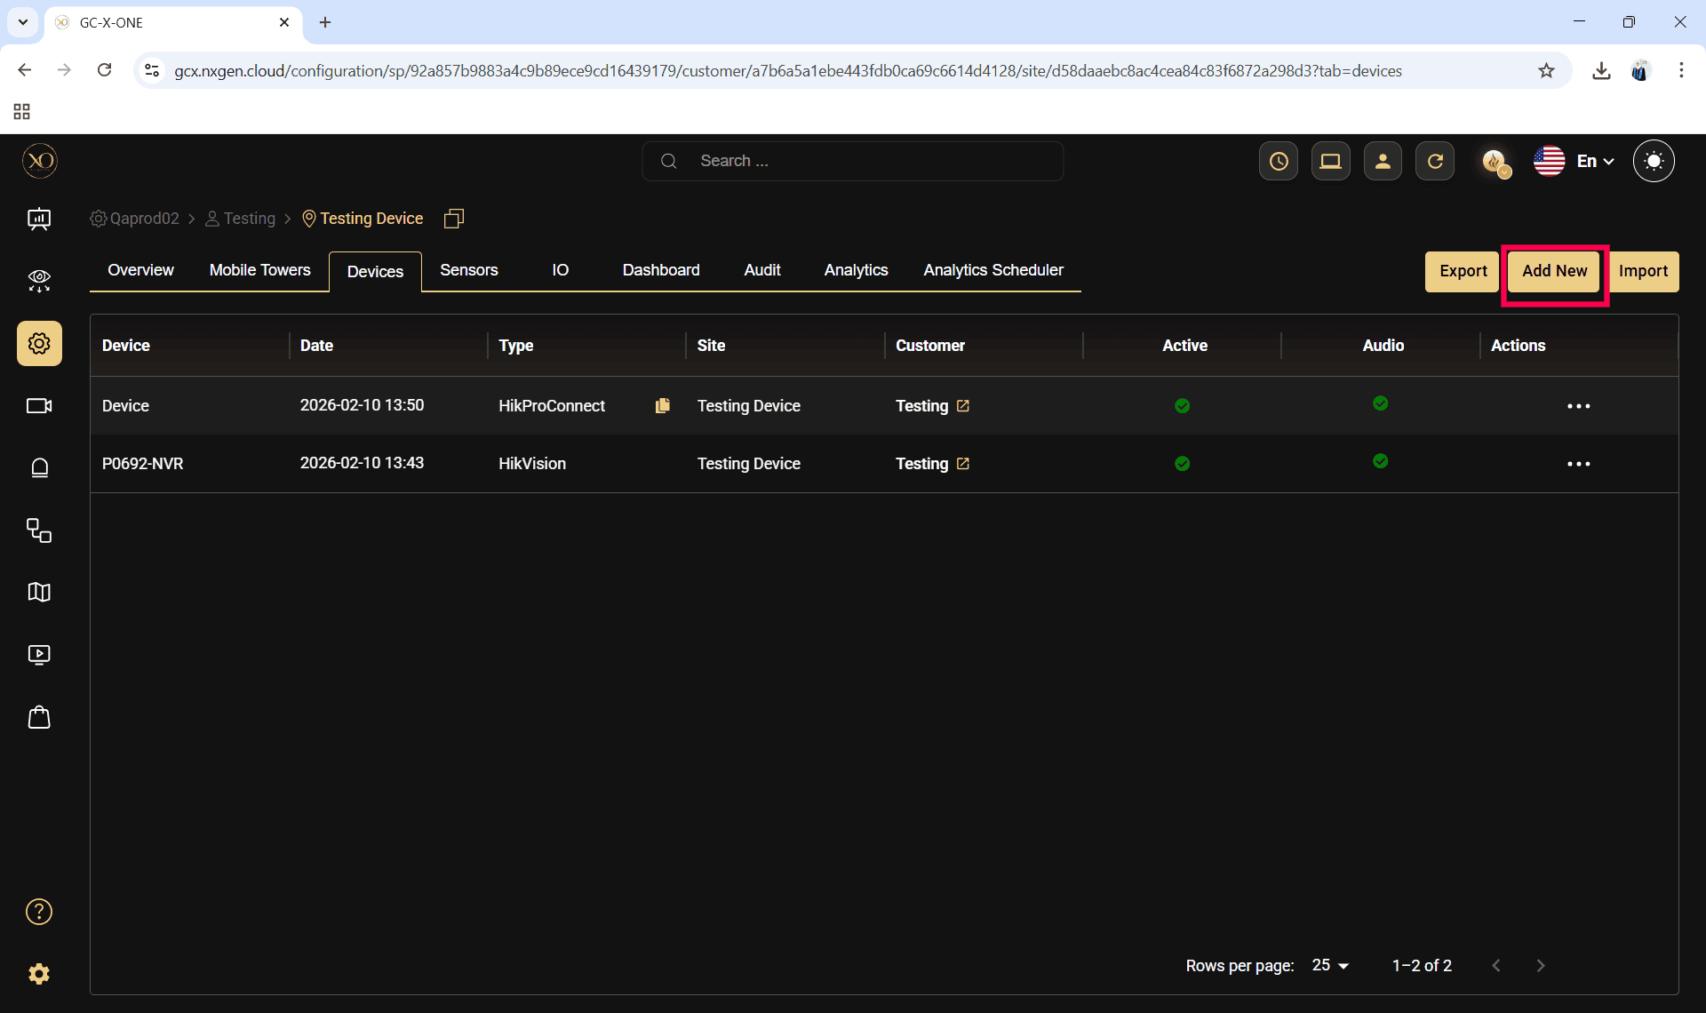

Step 13: The Add Device dialog will be displayed.
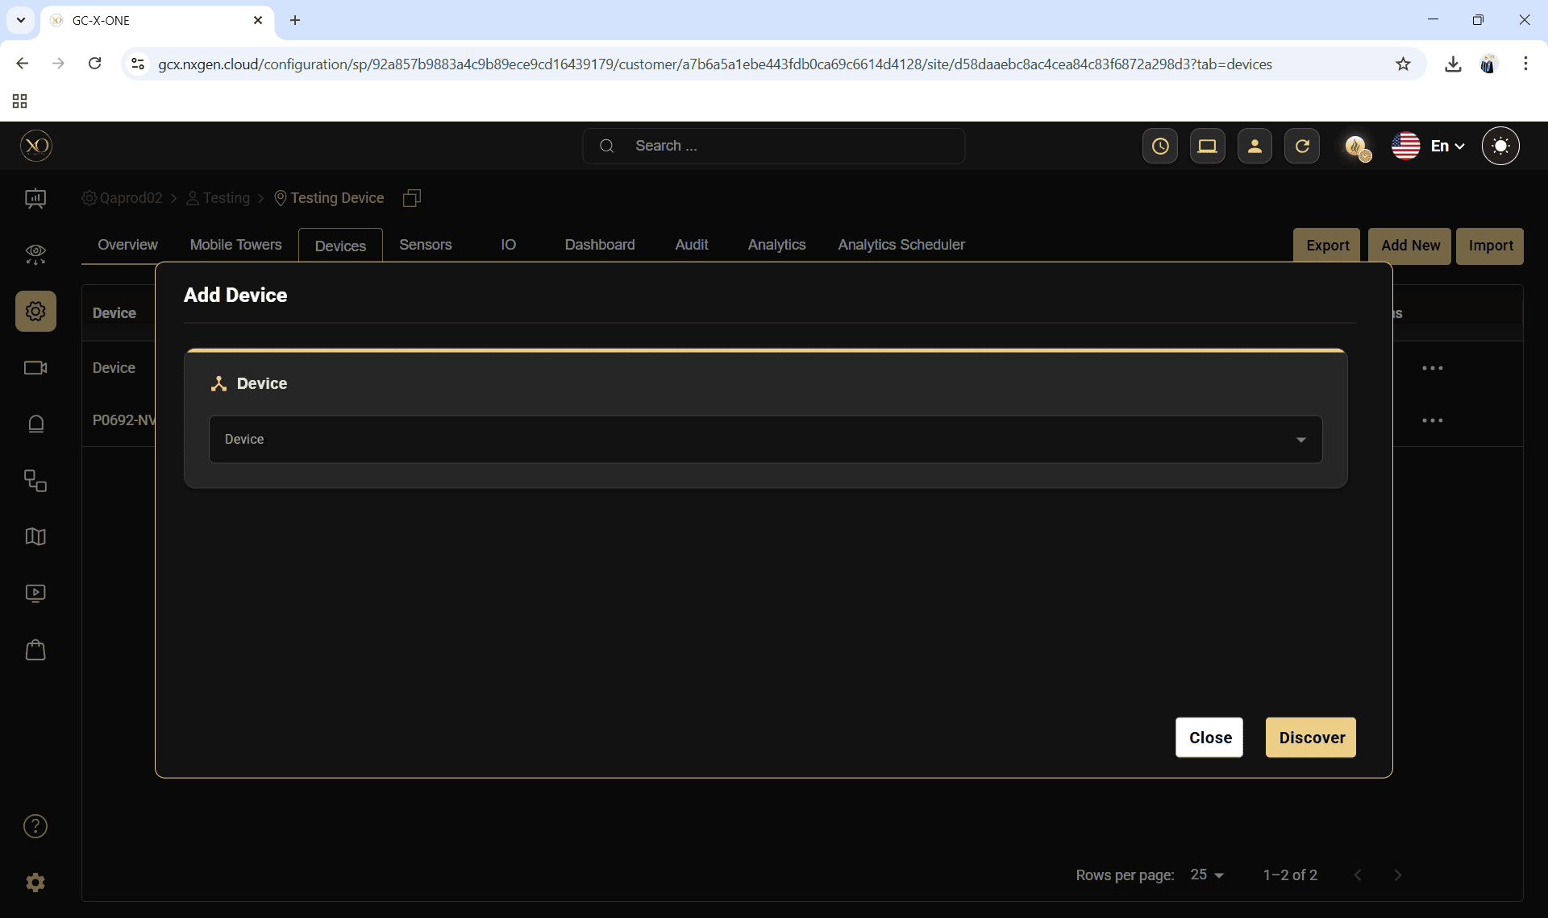

Step 14: In the dialog, open the Device dropdown and select Axxon.
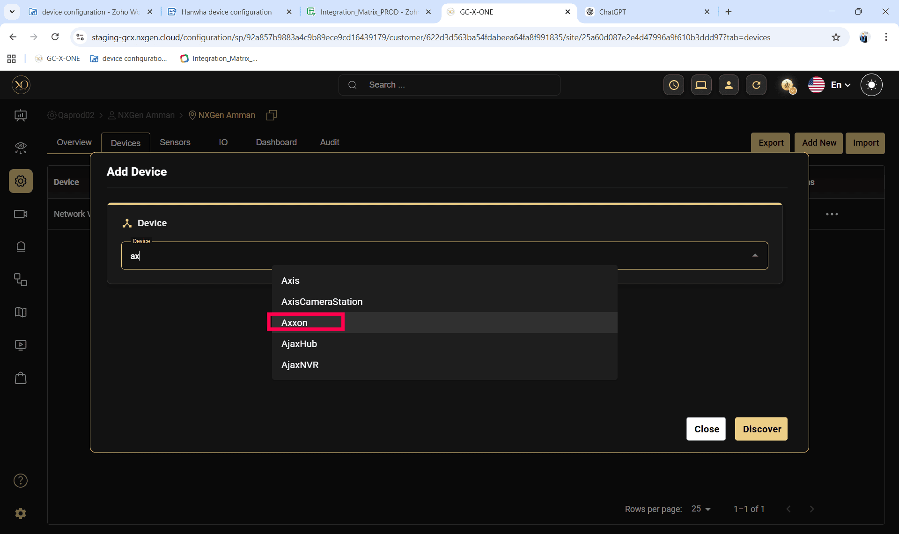

Step 15: Enter all required fields:
- "Name"
- "IP Address or Host"
- "Username"
- "Password"
- "RTSP Port"
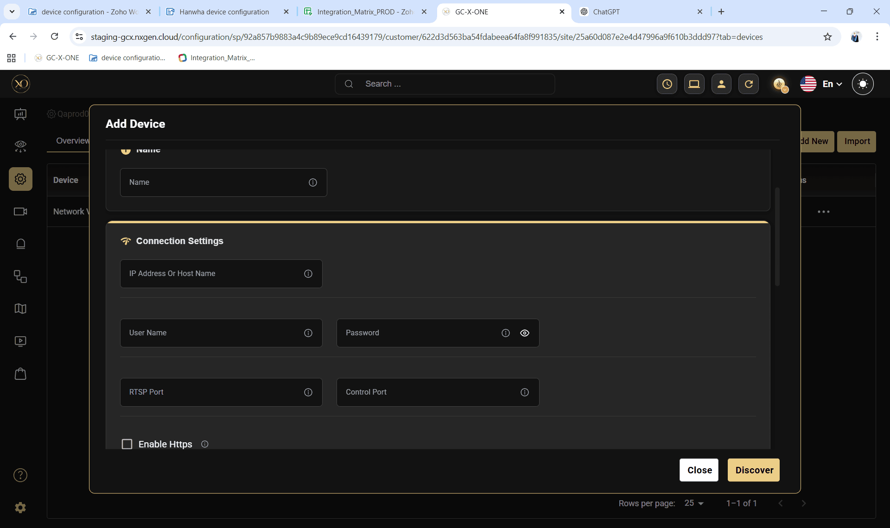
Step 16: Click Discover.

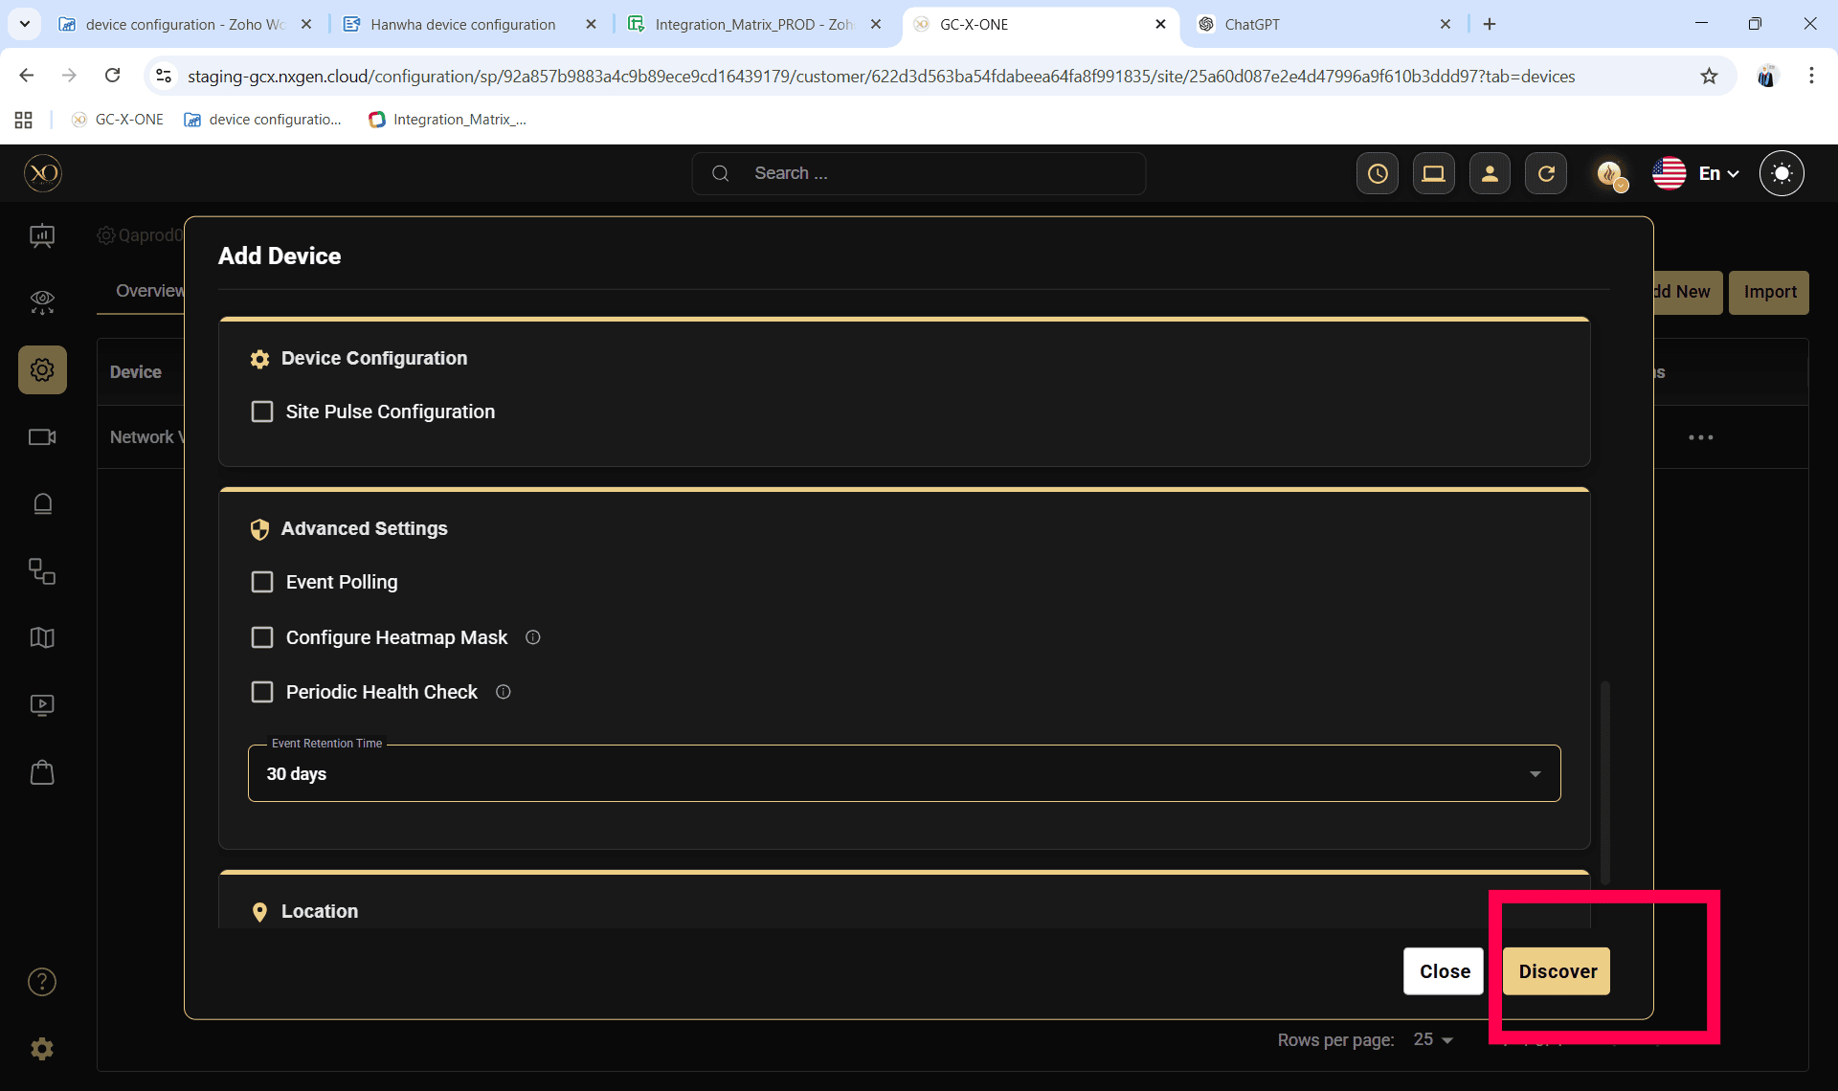Step 17: Once the device is successfully discovered, click Save.
